EXP:NO:01 PASSPORT AUTOMATION SYSTEM

USE CASE DIAGRAM:

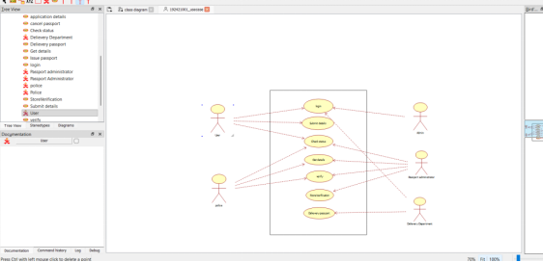

CLASS DIAGRAM:

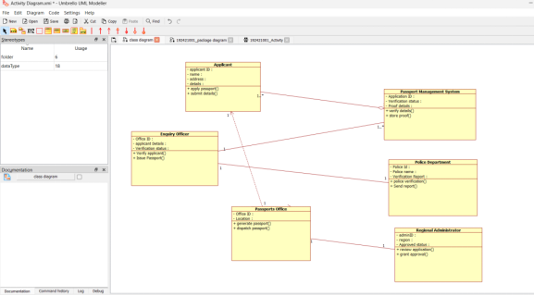

ACTIVITY DIAGRAM:

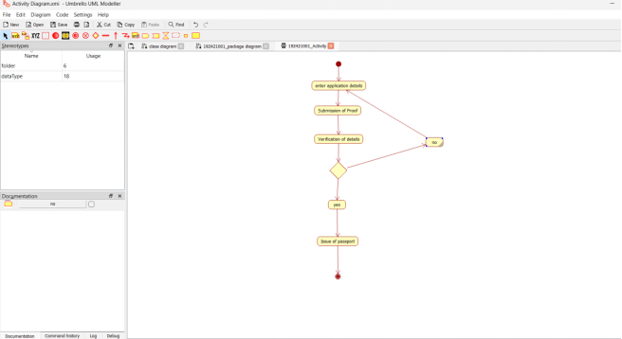

SEQUENCE DIAGRAM:
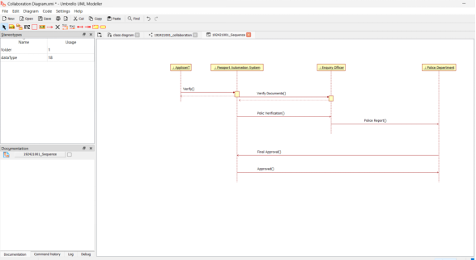

COLLABORATION DIAGRAM:

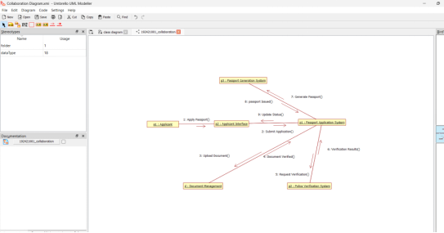

STATE CHART DIAGRAM :

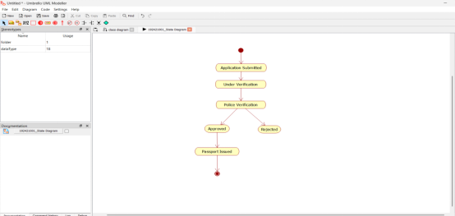

COMPONENT DIAGRAM
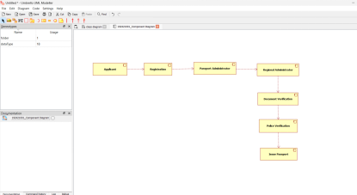

DEPLOYMENT DIAGRAM

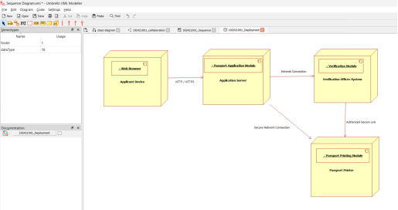

PACKAGE DIAGRAM:

